Timing/Blocks  Round 1 | Peer Coaching Circles -  Facilitator Roadmap Guide (April 2023)  1 ½ hours (90 Minutes) 2 Rounds
Block 1  10 minutes  Opening of Peer Coaching Circle  Facilitator Notes  Set your timer  What: Peer Coaching Circles  Practising/learning  Coaching Conversations Together  How: Roles, Process & Flow  Video Resource Joining a Peer Coaching Circle? What to Expect  https://youtu.be/grhDrO0Uhyg  Learning Environment  Let them set their learning space, provide reflection time to identify then share  Video Resource Selecting a Coaching Topic  https://youtu.be/H0GypcUOzmM  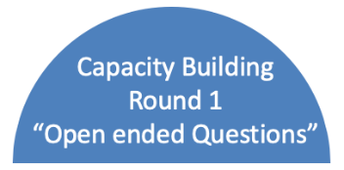  You are introducing: Asking Open ended questions  The learning and teaching moments are in the practicing and reflection in each round  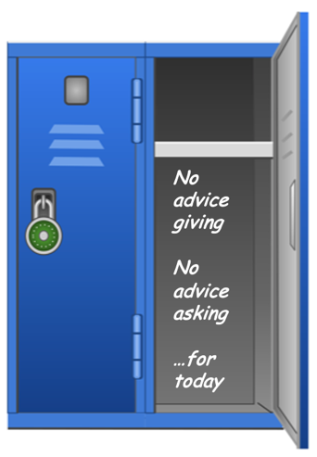 | Welcome/Flow  - Settling in  - Peer Coaching Circles Roles & Process  - Learning Space  - Capacity Building  - Round 1  - Short Break  - Capacity Building  - Round 2  - Wrap-up  Administration:  Something to take notes on  Cameras and microphones are on, to make this a small intimate setting  Introductions -- Check-in  Set-up: Self awareness + Listening = no response to the person’s check-in  Who are you? (Name, Department) and one or two words to describe how you are, coming into this space (You can model Jane Doe, Department, tired and ready)  Setting up Peer Coaching Circles  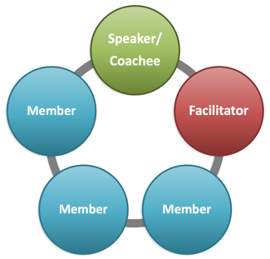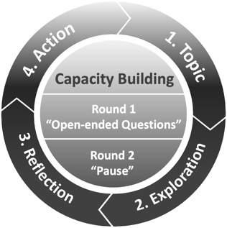  - Use PDF/Visual to touch on Roles and Process  - Roles – Speaker/Coachee, Members and Facilitator  - Review of process  Topic - Speaker/Coachee will share their topic  Exploration - Then members will practice group coaching  Reflection - members capture learning, coachee captures next steps/action  Action – Speaker/Coachee shares their action/next steps, All share their learning  - Capacity Building -- Let them know you will share more about capacity building for each round in a couple of minutes  - Learning Environment:  Facilitator Instructions  - Remind -- Vegas Rules (Confidentiality)  - Pose question: Anything else you need to fully participate and feel comfortable?  - Provide them 1 minute to reflect and share (can use chat as part of time management to share)  - Have them all look at chat results. Then pose Question: Anything else you need to fully participate and feel comfortable? (You type add-in whatever is proposed no responding) Learning space is set  - Set up Round 1  - Identify – 2 people who are willing to be coached and who will do Round 1 and Round 2. Rest will be members (Good Practice is to set-up who will be in which roles prior to session, if possible)  - Describe your role. Facilitator takes care of time, moderates the pace (so it doesn’t turn into rapid questions) and supports the learning  - Person being coached is the driver in the conversation, and does not have to have to answer any question they don’t want to.  Round 1: Learning/Capacity Building– Asking open ended questions  Share on screen Hand-out/PDF-- Practicing Asking Questions (Awareness and Practice):  Watch for,” the Deadly Three”  • Closed Questions – they illicit ‘yes or no’ response  • Leading Questions – may be focussed on the topic and directing them where you want them to go  • Preamble / Paraphrasing – e.g., so what I hear you say is…., I want you to know that this is something I relate to as well and so on…and so on… (limit the preamble, in order to create more airtime for coachee which makes it easier for them to hear and focus on the question)  Try for…  • Asking open ended questions – Start with, What, How, Where, When  • Short questions – less words creates clarity and are easily digestible  Locker Visual on PDF  **Put your Advice Giving muscle in the locker – Advice Giving and Advice Asking Free Zone…for next (number of minutes?)  (Advice Giving is Automatic, already good at this, the learning is -- letting them find their own answers/solutions)  Breathing Practice -- 1 minute
Block 2  5 minutes    Facilitator Notes:  Set your timer  Pen and Paper to capture observations  Airtime—This is a listening space, let the Speaker/Coachee speak without interruption  Reflection Ask Speaker/Coachee to take a minute to reflect and write down. Then ask them to share their what they wrote  **Starting point for exploration… More clarity will unfold during the member coaching in Block 3 | Speaker/Coachee Air Time (Person being coached) Listening Space  - Invite Speaker/Coachee to share their topic and what they would like the coaching to be focussed on.  - Facilitator can ask clarifying questions (only if needed) to help support where the Speaker/Coachee wants to focus the coaching conversation  - 1 minute before closing of air time, ask Speaker/Coachee to reflect and write down (journal) what they would like the coaching focus to be around, in their topic. Journal --‘Today I would like to focus on this specific area....’ or  ‘I am looking to explore the following today....’ around my coaching topic…  - Have them share what they wrote…That way, they state the coaching request in THEIR words  - Write down what they share, so you have it as a reference/visual for yourself.
Block 3  15 minutes    Facilitator Notes:  Set your timer  Don’t feel like you have to ask questions or do a lot of correction - Round 1 is for all to settle-in  Pace; ask Speaker/ Coachee if they are ready for another question. Provide moments for coachee to write down their thoughts/answers  Around 8 min mark—check-in with Speaker/Coachee if questions are supporting them  Capture some observations/examples for your learning feedback (Block 7) | Members - Coaching Conversation practise  - Members take turns practising coaching and asking open ended questions - Let them know, if they have a question to put their hand up and you will engage them  - Facilitator ensures the Speaker/Coachee has a chance to capture their thoughts on paper and is ready for the next question (moderating the pace)  - Facilitator provides light/minimal correction for round 1  - Take note of examples for facilitator observations and feedback for block 7. (Not specific notes on each person, focusing more on general observations i.e., some budding good questions and perhaps a note or two on leading/advice giving, closed questions or preambles;)  - 2-minute mark should be last questioned asked  - Once time is up, thank Speaker/Coachee for sharing their topic and willingness to be coached. Resist temptation to go into any detail! This is a way to quietly close this part of the peer coaching process.
Block 4  4 minutes Total    Facilitator Notes:  Set your timer  Start with Task #1 for Speaker/Coachee and Member  Set Timer 1 ½ minutes  Then do Task #2 for Speaker/Coachee and Members  Set Timer 1 ½ minutes  Do each task one at a time, shows distinction and bite size instructions easy to follow and digest | Group Reflection and Journal  Task #1 - Reflect and Journal (1 ½ minutes)  -Speaker/Coachee – What action(s) will I commit to as a next step?  -Members - Take away question for the Speaker/Coachee (have them write in their journal/paper)  (Let them know you are giving them 1 ½ minutes to do this on their own)  -Facilitator- You will take this time to review your notes and capturing a couple observations and learning, for the group’s growth and development (focus on asking open ended questions)  Task #2 - Reflect and Journal (1 ½ minutes)  -Speaker/Coachee – What is my own learning being coached?  -Members - What did I learn about asking open ended questions?  (Let them know you are giving them 1 ½ minutes to do this on their own)  -Facilitator – Continue capturing your observations and learning for the group’s growth
Block 5  4 minutes    Facilitator Notes:  Set your timer  Do each task one at a time, shows distinction and bite size instructions easy to follow and digest | Speaker - Action/Learning  Task #1 - Facilitator asks Members to:  - Share their takeaway question for the Speaker/Coachee  - Speaker/Coachee listens to members take away questions (doesn’t answer)  **Ask Members to type their question in chat  Task #2 - Facilitator asks Speaker/Coachee to:  - Share their action(s)/next step(s)  Task #3 - Facilitator asks Speaker/Coachee to:  - Share their top 2 personal learnings on being coached/peer coaching experience  Offer Speaker/Coachee to cut and paste takeaway questions from chat
Block 6  3 minutes  Facilitator Note:  Set your timer  Set-up ask them to share their learning about what if felt like for them to practice (self-awareness) around asking open-ended questions. (This isn’t about the Speaker/ Coachee) | Members Action/Learning  - Let them know they have 1 minute each (based on 3 members) to share their Top 2 Personal Learnings (about themselves), on asking open ended questions
Block 7  3 minutes  Facilitator Note:  Set your timer  Recognize effort to ask questions, feedback with a couple of examples that would help with awareness and learning.  Video Resource - The Feedback Model Video  https://youtu.be/fthp2Ns6vrk | Facilitator Observations  - Top 3 Group observations for learning and development (asking open ended questions and any greatness you saw and where the group could try practising next round, from your observations i.e., less leading questions or preambles, whatever you notice)  Short bio-Break--Ask them to be back (Provide the clock time) to set-up second round
Block 8  3 minutes | Break
Timing/Blocks  Round 2 | 1 ½ hours (90 minutes) -- Agenda/Roadmap 2 Rounds
Block 1  3 minutes  Facilitator Notes  Set your timer  Confirm with Speaker/Coachee they are ready to start  Ask for permission for support re-shaping a closed or leading question in the process  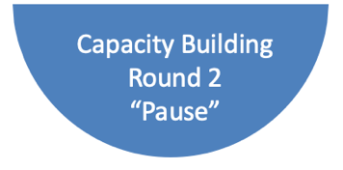 | Facilitator  - Re-set Round 2 of Peer Coaching  - Speaker/Coachee identified at start (re-confirm now)  - For this round ask Members permission, to offer the opportunity to do some re-shaping of their questions with them, for learning and growth (i.e., opportunity for rephrasing questions from closed to open; or from leading to non-leading)  - Reminder - Speaker/Coachee does not have to answer any question  Round 2: Learning/Capacity Building – Asking open ended questions plus the practice of pause to leave time/quiet space, for person being coached to add more in i.e., after the Speaker/Coachee has written something down or answered a question, allow a pause for them, to fully process their response to a question and to continue to ‘think out loud’  Members are also continuing the practice of asking open ended questions
Block 2  5 minutes  Facilitator Notes  Set your timer  Pen and Paper to capture observations  Airtime—This is a listening space, let the Speaker/Coachee speak without interruption  Reflection Ask Speaker/Coachee to take a minute to reflect and write down. Then ask them to share their what they wrote  **Starting point for exploration… More clarity will unfold during the member coaching block | Speaker/Coachee Air Time (Person being coached) Listening Space  - Invite Speaker/Coachee to share their topic and what they would like the coaching to be focussed on.  - Facilitator can ask clarifying questions (only if needed) to help support where the Speaker/Coachee wants to focus the coaching conversation  - 1 minute before closing of air time, ask Speaker/Coachee to reflect and write down (journal) what they would like the coaching focus to be around, in their topic. Journal --‘Today I would like to focus on this specific area....’ or  ‘I am looking to explore the following today....’ around my coaching topic…  - Have them share what they wrote… That way, they state the coaching request in THEIR words  Write down what they share, so you have it as a reference/visual for yourself.
Block 3  15 minutes  Facilitator Notes:  Set your timer  Light correction, if opportunity arises, ask for permission (again). 1 or 2 times is the max within the 15 min window  Pace; Ask Speaker/ Coachee if they are ready for another question. Provide moments for Speaker/ Coachee, to write down their thoughts/answers  Around 8 min mark—check-in with Speaker/ Coachee if questions are supporting them  Capture some observations/examples for your learning and feedback (Block 7) | Members - Coaching Conversation practise  - Members take turns asking questions. Remind them if they have a question to put their hand up  - Facilitator ensures the Speaker/Coachee has a chance to capture their thoughts on paper and is ready for the next question  - Facilitator --- Light correction for learning if needed. As a moderator, you can let the question be presented and then ask the member to play with you.  - For Example - A question with an advice-giving/leading focus (hint -- they may have started with ‘have you thought of…’), is an opportunity to invite them, to re-state the question using -- what, how etc., to make it an open-ended non-leading question).  - Offer them a minute to pause (which is the capacity building for round 2) to write it down and then share. - Once they share, thank them for the opportunity to learn in the moment.  - Take notes on observations and examples of asking open ended questions, and the new capacity building of pause (continue with general group observations) this will be shared in block 7 (facilitators observations/feedback)  - Once time is up, thank the Speaker/Coachee for sharing their topic and their willingness to be coached. Resist temptation to go into any detail! It is a way to quietly close this part of the peer coaching process.
Block 4  4 minutes  Facilitator Notes:  Set your timer  Start with Task #1 for Speaker/Coachee and Member  Set Timer 1 ½ minutes  Then do Task #2 for Speaker/Coachee and Members  Set timer 1 ½ minutes  Do each task one at a time, shows distinction and bite size instructions easy to follow and digest | Group Reflection and Journal  Task #1 - Reflect and Journal (1 ½ minutes)  -Speaker/Coachee – What action(s) will I commit to as a next step?  -Members - Take away question for the Speaker/Coachee (have them write in their journal/paper)  (Let them know you are giving them 1 ½ minutes to do this on their own)  -Facilitator- You will take this time to review your notes and capturing a couple observations and learning, for the group’s growth and development (focus on asking open ended questions and the practice of pause).  Task #2 -Reflect and Journal (1 ½ minutes)  -Speaker/Coachee – What is my own learning being coached?  -Members - What did I learn about asking open ended questions and creating space for pause?  (Let them know you are giving them 1 ½ minutes to do this on their own)  -Facilitator – Continue capturing your observations and learning for the group’s growth
Block 5  4 minutes  Facilitator Notes:  Set your timer  Do each task one at a time, shows distinction and bite size instructions easy to follow and digest | Speaker - Action/Learning  Task #1 - Facilitator asks Members to:  - Share their takeaway question for the Speaker/Coachee  - Speaker/Coachee listens to members take away questions (doesn’t answer)  **Ask Members to type their question in chat  Task #2 - Facilitator asks Speaker/Coachee to:  - Share their action(s)/next step(s)  Task #3 - Facilitator asks Speaker/Coachee to:  - Share their top 2 personal learnings on being coached/peer coaching experience  Offer Speaker/Coachee to cut and paste takeaway questions from chat
Block 6  6 minutes  Facilitator Note:  Set your timer  Set-up ask them to share their learning about what if felt like for them to practice (self-awareness) around asking open-ended questions. (This isn’t about the Speaker/ Coachee) | Members- Action/Learning  - Let them know they have 2 minutes each (based on 3 members) to share their Personal Learning (about themselves) on asking open ended questions, pause, and peer coaching process  - And to share one takeaway, for them to practice in conversations. (To continue their learning and practice)
Block 7  6 minutes  Facilitator Note:  Set Timer  Recognize effort and courage to practice and ask questions, your feedback with a couple of examples will help with awareness and learning. | Facilitator Observations  - Top 3 Group observations for learning and development. Recognize the learning and growth and continued learning and practice. (Less is More, they have been in full on listening and practising!)  - Close-down the Peer Coaching Circle Practice. Share your ongoing learning for yourself (as you are in a learning seat too), thank them and if this is an ongoing group, set the next date.

